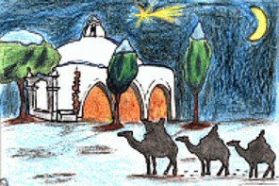

Queridos Reyes Magos:

-----------------------------------------------------------------------------------------

-----------------------------------------------------------------------------------------------------

-----------------------------------------------------------------------------------------------------

-----------------------------------------------------------------------------------------------------

-----------------------------------------------------------------------------------------------------

-----------------------------------------------------------------------------------------------------

-----------------------------------------------------------------------------------------------------

-----------------------------------------------------------------------------------------------------

-----------------------------------------------------------------------------------------------------

-----------------------------------------------------------------------------------------------------

-----------------------------------------------------------------------------------------------------

-----------------------------------------------------------------------------------------------------

http://www.menudospeques.com

