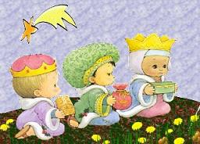

Queridos Reyes Magos:

-------------------------------------------------------------------------------------------

-------------------------------------------------------------------------------------------------------

-------------------------------------------------------------------------------------------------------

-------------------------------------------------------------------------------------------------------

-------------------------------------------------------------------------------------------------------

-------------------------------------------------------------------------------------------------------

-------------------------------------------------------------------------------------------------------

-------------------------------------------------------------------------------------------------------

-------------------------------------------------------------------------------------------------------

-------------------------------------------------------------------------------------------------------

-------------------------------------------------------------------------------------------------------

-------------------------------------------------------------------------------------------------------

http://www.menudospeques.com

