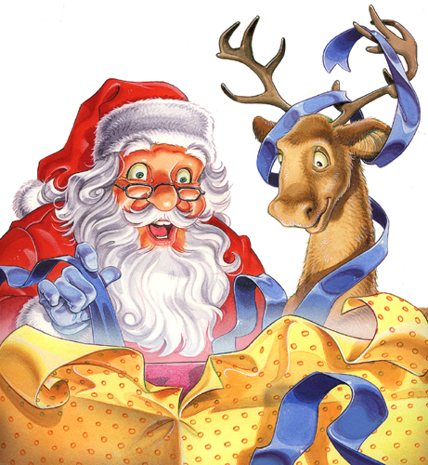

Querido Santa:

_____________________________________________________________

___________________________________________________________________

___________________________________________________________________

___________________________________________________________________

___________________________________________________________________

___________________________________________________________________

___________________________________________________________________

___________________________________________________________________

___________________________________________________________________

___________________________________________________________________

___________________________________________________________________

___________________________________________________________________

http://www.menudospeques.com

